Vision Rehabilitation Workforce Survey

A report for RNIB and RWPN

Evaluation Services

Contents
Introduction 1
The vision rehabilitation workforce 2
Organisations and CPD 5
Other topics in vision rehabilitation 8

Contact:
Matthew Terry
Director, Cloud Chamber Limited
matthew.terry@cloud-chamber.co.uk
www.cloud-chamber.co.uk
May 2017

Introduction

About the survey
The Royal National Institute for the Blind (RNIB) and the Rehabilitation Workers Professional Network (RWPN) commissioned as survey of the Vision Rehabilitation workforce in the Spring of 2017. This report presents findings from the survey, which was administered by Cloud Chamber as part of their wider evaluation of the RNIB’s Early Intervention and Rehabilitation Project, funded by the Department of Health.
This survey constitutes the first attempt to capture the characteristics of the vision rehabilitation workforce, as well as an opportunity to gather opinions on the current state of the profession and the professional body.

Methodology
The workforce survey was designed by the RNIB and RWPN, with advice and guidance from Cloud Chamber. The survey was administered online via Cloud Chamber (through the Surveymonkey platform), and received 161 responses over a four-week period between 20 March 2017 and 13 April 2017. We are unable to determine with precision an overall population for the rehabilitation workforce, so cannot be certain of the statistical robustness of this sample. However, we consider it likely that the survey captured a large proportion of the vision rehabilitation workforce, based on informal estimates that around 200 individuals work in vision rehabilitation across the UK.
Respondents were targeted through the membership lists of the RWPN and the survey was promoted to the broader profession through events attended by the RNIB’s project manager.

About this report
The report covers the following subjects:
- The structure and characteristics of the vision rehabilitation workforce (Section 2)
- The characteristics of organisations involved in vision rehabilitation and continuous professional development for the workforce (Section 3)
- Information and opinion on other topics in vision rehabilitation including caseload volume and complexity, best practice, and the professional body (Section 4)

The vision rehabilitation workforce

Gender, age and location
The results of the survey show that there is a distinct majority of females working within the vision rehabilitation sector. The majority of respondents were female, representing over three quarters or 76% of respondents (n=151).
Respondents were most commonly aged between 45 to 54 (38%) and 64% of were aged between 45 and 64. The distribution of age is shown in Figure 1, indicating that the workforce is ageing with a clear skew towards older age groups.
Figure 1: Respondents by age
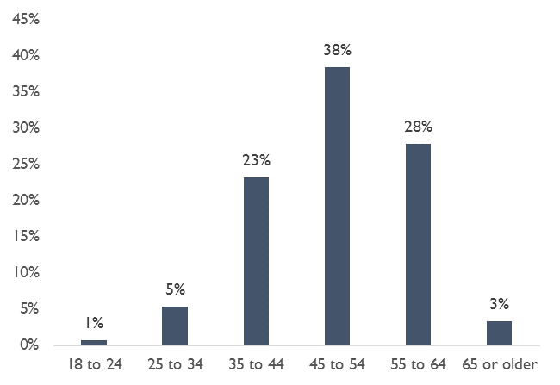
Source: Vision Rehabilitation workforce survey. N=151
Examining the age profile of respondents by gender (Figure 2) shows there is little difference between the gender profile of different age groups within the sample.
Figure 2: Respondents’ age by gender
 | % Female | % Male | N
18 to 24 | 100% | 0% | 1
25 to 34 | 75% | 25% | 8
35 to 44 | 74% | 26% | 35
45 to 54 | 81% | 19% | 57
55 to 64 | 76% | 24% | 41
65 or older | 60% | 40% | 5
Prefer not to say / skipped question | 75% | 25% | 8
All ages | 76% | 24% | 155
Source: Vision Rehabilitation workforce survey. N= 155

The most common geographic regions respondents were located in were the South East (19%), the Midlands (18%) and London (15%). Fewer respondents were based in Northern Ireland (1%) and Wales (5%).
Figure 3: Respondents by region
Region | Total | %
North West | 11 | 7%
North East | 15 | 10%
Midlands | 27 | 18%
East Anglia | 11 | 7%
London | 23 | 15%
South West | 11 | 7%
South East | 28 | 19%
Wales | 7 | 5%
Scotland | 15 | 10%
Northern Ireland | 2 | 1%
Source: Vision Rehabilitation workforce survey. N=150

Roles and qualifications
The vast majority of respondents described themselves as Rehabilitation Workers or Officers (91%). There were a small number of assistant vision rehabilitation officers (4%) and 7% classified their role as ‘other’. Occupations listed in free-text responses under this ‘other’ category included Social Worker / Rehabilitation Officer, Social Care Manager, Habilitation Specialist (2), Manager of Services (2), Academic, Advanced Practitioner, O&M Instructor / Technical officer, Church Disability Advisor and Eye Clinic Liaison Officer.
Respondents were asked to report their highest level of qualification and whether they held a specialist vision rehabilitation qualification. Most commonly, respondents were educated to Level 5 with nearly two fifths of respondents having a foundation degree, HND, DipHE or equivalent. 35% were qualified to level 6 (e.g. bachelor’s degree) and 13% to level 4 (e.g. Cert HE).
Figure 4: Respondents’ highest qualification by level
Qualification level | Total | %
Entry or Level 1 (e.g. Level 1 NVQ, GCSE's grade D,E,F or G) | 2 | 1%
Level 2 (e.g. GCSEs grade A*-C, intermediate apprenticeship, SQC's) | 6 | 4%
Level 3 (e.g. A/AS levels, advanced apprenticeship, Scottish Highers) | 3 | 2%
Level 4 (e.g. Certificate of Higher Education, Higher National Certificate, Level 4 NVQ) | 21 | 13%
Level 5 (e.g. Foundation degree, HND, DipHE) | 61 | 39%
Level 6 (e.g. Bachelors Degree) | 55 | 35%
Level 7 (Master's degree, PGCE) | 8 | 5%
Level 8 (e.g. PhD, DPhil) | 1 | 1%
Total | 157 | 100%
Source: Vision Rehabilitation workforce survey. N=157
All respondents reported holding a specialist vision rehabilitation qualification, most common of which were foundation degrees (29%), Diplomas in Higher Education (20%) and BTEC (20%). Full results are shown in Figure 5 below.
Figure 5: Respondents by type of specialist qualification
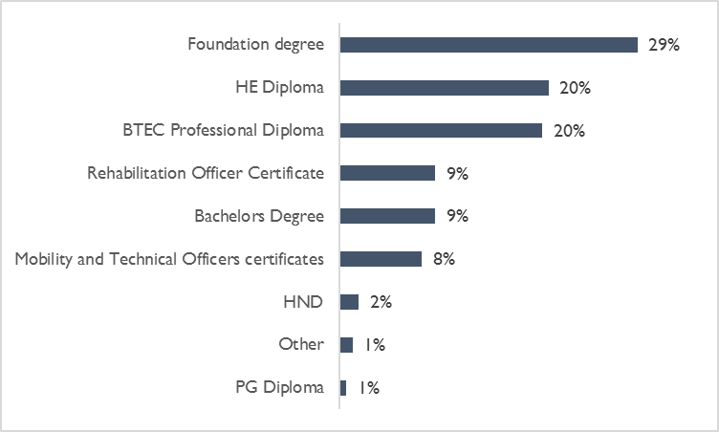
Source: Vision Rehabilitation workforce survey. N=161

Employment status
The majority of respondents were employed full-time (73%). A fifth were employed part-time and 2% were self-employed (n=157). Nine respondents stated ‘other’ as their employment status. Free-text responses included agency or sessional workers (4), company director (1), retired but active in the field (1), under notice for compulsory redundancy (1) and working as part of another profession (1).
Respondents tend to be experienced, with two thirds (66%) having worked in vision rehabilitation for over 10 years. A full breakdown is shown in Figure 6 below.
Figure 6: Respondents’ reported time working in vision rehabilitation (n=157)
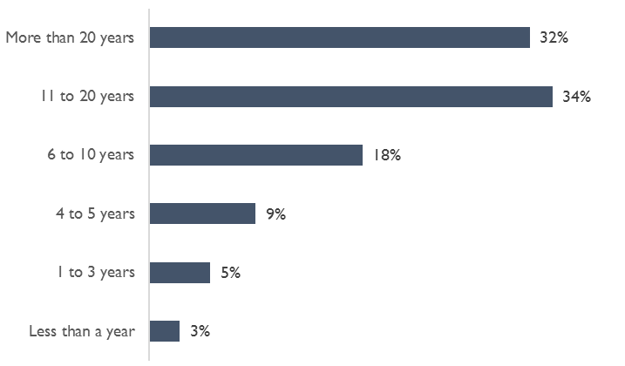
Source: Vision Rehabilitation workforce survey. N=157

Organisations and CPD

Employers
Local Authorities were the most common type of employer of respondents; 61% were employed by Local Authorities and 16% by national charities. A summary of responses can be found in Figure 7.
Figure 7: Respondents by employing organisation
Type of employing organisation | Respondents | %
Local Authority | 88 | 61%
National charity | 23 | 16%
Local sight loss charity | 16 | 11%
Private organisation | 3 | 2%
Other | 15 | 10%
Total | 145 | 100%
Source: Vision Rehabilitation workforce survey. N=145
Of the 16 respondents working for local sight loss charities, the majority (88%) reported their organisations to be under contract to deliver local authority sight loss services.

Supervision
The large majority of respondents (92%) received some form of supervision. The frequency of supervision is shown in Figure 8 below, with nearly a half of respondents (49%) receiving supervision once a month and a fifth every over month.
Figure 8: Frequency of supervision
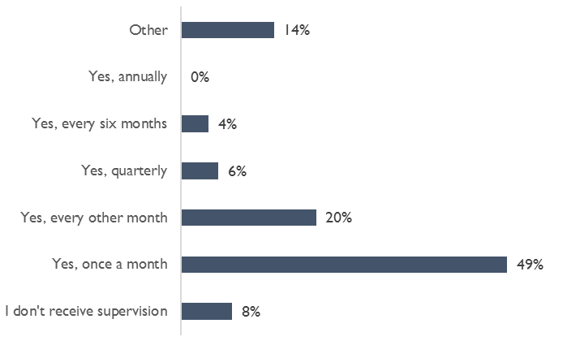
Source: Vision Rehabilitation workforce survey. N=144
A small proportion (14%) stated some other frequency or arrangement with respect to the supervision they received; for example, every six weeks (6), sporadic or ad hoc (3), limited (3), ‘random’ or ‘every few months and from non-technical perspective’ (2) and regularly postponed (2).
Related to supervision arrangements, the survey also explored the extent to which vision rehabilitation services were being managed by individuals with expertise or experience of working in the field. Nearly one third of respondents (31%) reported that their managers possessed some other related qualification (such as occupational therapy or social work) but had little or no experience of running a rehabilitation service. 28% of respondents stated that their managers had specialist qualifications in vision rehabilitation. Full details are shown in Figure 9.
Figure 9: Managerial experience within vision rehabilitation (n=141)
Type of employing organisation | %
A non-visual impairment Occupational Therapy or Social Work qualification, but little or no experience of running a visual rehab service | 31%
Vision rehab qualification | 28%
A non-visual impairment Occupational Therapy or Social Work qualification, and experience of running a visual rehab service | 18%
No experience of being a front line practitioner in the NHS/Social Care | 9%
Other | 14%
Total | 100%

Continuous professional development
The majority of respondents (78%) felt their organisation supported continuous professional development (n=143). Respondents were asked to rate how supported by their manager they felt on a scale of 1 to 7 (where 7 = fully supported) and in general there was a good level of support on offer with respondents on average rating the support received as 5.2 out of 7. Similarly, when asked whether the organisation supported in doing their job, respondents on average rated this as 4.6 out of 7. The full distribution of scores is shown in Figure 10 below.
Figure 10: Provision of support from management and organisation
 | Manager supports CPD |  | Organisation supports the job we do
 | N | % | N | %
No support at all (1) | 6 | 4% | 10 | 7%
2 | 7 | 5% | 12 | 8%
3 | 16 | 12% | 14 | 10%
4 | 14 | 10% | 35 | 24%
5 | 24 | 17% | 24 | 17%
6 | 24 | 17% | 17 | 12%
Full support (7) | 47 | 34% | 31 | 22%
Total | 138 | 100% | 143 | 100%
Source: Vision Rehabilitation workforce survey
Respondents were asked about the areas of CPD they had undertaken in the past three years, and what areas of CPD might be beneficial to them or their clients in the future. Assistive technology was the most commonly cited area of CPD undertaken over the past three years (25%), followed by orientation and mobility (20%) and supporting service users with complex needs (16%). Many respondents had other areas of CPD they had undertaken in the last three years (17%) and prominent areas included supporting Deafblind people, training responding to legislation, dementia, and safeguarding.
Vision rehabilitation professionals were asked what CPD opportunities might be beneficial to their career or the service provided to clients over the next three years. Respondents provided open-ended responses, and we have coded these as per Figure 11 below. The most commonly cited area of CPD was in assistive technology, with 13% of responses mentioning the need for development in this area.
Figure 11: Areas where additional CPD would be welcomed
CPD Area | Number of citations | % of total
Assistive technology | 14 | 13%
Dementia | 9 | 8%
Complex needs | 8 | 7%
Psychology, Emotional support and resilience | 6 | 6%
Low vision | 5 | 5%
Children and young people | 4 | 4%
Mobility with pushchairs or wheelchairs | 4 | 4%
Orientation and mobility | 4 | 4%
Deaf Blind | 3 | 3%
Mental health | 3 | 3%
Orientation and mobility for complex needs | 3 | 3%
Autism | 2 | 2%
Brain injuries | 2 | 2%
Drug & alcohol misuse | 2 | 2%
Information technology | 2 | 2%
Mobility refresher | 2 | 2%
Orientation and mobility refresher | 2 | 2%
Scholarship | 2 | 2%
Stroke | 2 | 2%
Supervision | 2 | 2%
Other | 29 | 27%
Total | 108 | 100%
Source: Vision Rehabilitation workforce survey. Free-text responses coded by CCL

Other topics in vision rehabilitation

Caseload volumes and complexity
Respondents were asked their opinions on the volume and complexity of their caseloads. The complexity of case work is increasing over time according to our survey respondents, with nearly three quarters (74%) reporting the needs of their clients had become more complex over time. Just under a sixth (15%) thought clients’ needs had not become more complex, while 10% did not know (n=143).
Respondents were asked what the implications of changes in caseload complexity were to their practice, and these are set out in Figure 12. Respondents most commonly reported time and or resource pressures (27%) and the need for more CPD to deal with complexity (26%).
Figure 12: Implications of changes in complexity on vision rehabilitation practice
Implication | Number of citations | % of total
Time and/or resource pressure | 32 | 27%
More CPD required to deal with complexity | 30 | 26%
Closer partnership working with other agencies | 14 | 12%
Covering other social care or rehabilitation issues without necessary expertise (e.g. hearing) | 11 | 9%
Other needs reduce the impact of rehabilitation | 4 | 3%
More research undertaken prior to appointments | 3 | 3%
Keeping up to date | 2 | 2%
Responsive service, not planning for the long-term | 2 | 2%
Lack of support or training | 2 | 2%
Other | 17 | 15%
Total | 117 | 100%
Source: Vision Rehabilitation workforce survey. Coded by CCL based on free-text responses
Responses in the other category included:

- Case volumes driving services
- Dealing with other conditions / issues
- Difficulty determining eligibility
- Difficulty managing caseloads
- Educate and train coworkers without vision rehab background
- Greater knowledge required
- Higher demand for alternative technology
- Increased crisis point interventions
- Less contact time with clients
- Less specialisation
- Longer waiting time for clients
- Makes the job more exciting and challenging
- More safeguarding issues
- More urgent and less holistic care provided
- None as clients are well screened, pre-appointment
- Specialist supervision
- Staff turnover
- Vision Rehabilitation Workers being used as Assistant Social Workers

The majority of respondents reported the volume of case work to have increased or stayed the same over the last six months. Just over half of respondents felt their caseload had increased (51%, n=142), 45% thought it had stayed the same and only 4% thought it had reduced.

Best practice
Through the RNIB’s early intervention project, work has been underway to define and disseminate good practice principles for the vision rehabilitation sector. To test the awareness, usefulness, and implications of the principles, a short section was included on the workforce survey.
There was a high awareness of RNIB’s 10 principles of good practice with 82% (n=130) stating that they were aware of the principles. One sixth of respondents (16%) weren’t aware and a further 7% didn’t know.
Respondents were asked the extent to which the principles affected their practice (see Figure 13). Nearly one quarter (23%) of respondents thought the implications of the 10 principles of good practice were limited personally, as they felt they were already implementing them.
Figure 13: Implications on practice of 10 good practice principles
Response | Number of citations | %
Principles already reflected in current practice | 23 | 23%
None | 17 | 17%
Justification/awareness raising of role to management | 8 | 8%
Generally a broadly useful framework | 5 | 5%
Not applicable | 5 | 5%
Not aware | 5 | 5%
Not sure | 5 | 5%
Limited because of caseloads and workforce | 4 | 4%
Helps set expectations | 3 | 3%
Helped me to be more reflective | 2 | 2%
Influenced training | 2 | 2%
Limited | 2 | 2%
Strategic planning | 2 | 2%
Timeframes are unrealistic | 2 | 2%
Useful reminder of particular elements of good practice | 2 | 2%
Other | 14 | 14%
Total | 101 | 100%
Source: Vision Rehabilitation workforce survey. Coded by CCL based on free-text responses

The professional body
Two thirds of respondents were RWPN members (n=137). Motivations for becoming members included receiving professional support, CPD, networking opportunities, and developing professional recognition.
Reasons cited for not being a member most commonly mentioned cost, and inaction on the part of the respondents themselves.
Respondents were asked the extent to which they were supported by RWPN on a scale of 1 to 7 (where 7=fully supported). On average respondents scored 4.58 out of 7 (n=118).
Nearly half of respondents (n=136) attended RWPN regional forums. A further 30% were not aware of the meetings and just over a quarter were aware of the meetings but chose not to attend (23%). Of those who attend, over two fifths (44%) attended every meeting while the remaining 66% said they attended occasionally (n=65).
Respondents were asked to name their three top priorities for support from the professional body. These are summarised in Figure 14 below. CPD was the top action in all three priorities. Registration of the profession was also frequently cited as a priority.
Figure 14: Top priorities for RWPN action
Priority 1 |  | Priority 2 |  | Priority 3
Area | % | Area | % | Area | %
CPD | 35% | CPD | 17% | CPD | 21%
Registration of the profession | 9% | Best practice | 6% | Information | 9%
Raising the profession's profile | 6% | Job opportunity dissemination | 6% | Raising the profession's profile | 9%
Not sure | 3% | Registration of the profession | 6% | Awareness raising with management / employers | 5%
Safeguarding jobs | 3% | Availability of assistive technology | 4% | Peer support | 5%
Specialised training | 3% | Awareness raising with management / employers | 4% | Registration of profession | 5%
Apprenticeship programme | 2% | Awareness raising within management | 4% | Apprenticeship programme | 4%
Assistive technology training | 2% | Information | 4% | Management support | 4%
Awareness raising within management | 2% | Raising awareness of sight loss | 4% | Pay and conditions | 4%
Information | 2% | Raising the profession's profile | 4% | Seminars | 4%
Job opportunity dissemination | 2% | Regional meetings | 4%
 |  | Specialist training | 4%
Source: Vision Rehabilitation workforce survey. Coded by CCL based on free-text responses. N=94 for priority 1, N=71 for priority 2 and N= 56 for priority 3.
Respondents were given opportunity to add other comments related to their role. It is clear from the responses that there is significant pressure on the rehabilitation officer/worker role within local authority settings:
- “As the last full time Rehabilitation Officer in my Local Authority (the team since I joined it has lost two full time rehab officer and one full time technical officer post as well as a part time dual sensory loss worker and three part time social care assessor posts) I feel the job is now no more than a fire fighting exercise with little appreciation evident of it's value.”
- “Only that I feel increasingly under pressure and considering I only qualified a few yeas ago, feel I am getting more and more beaten down by managers, policies and procedures. I'm not enjoying my job.”
- “It appears senior managers in some LA's are using the lack of statutory legislation regarding the provision of VI rehab to reduce services and costs. The preventative area of the Care Act has become an expense most will not fund.”
- “The cuts and policies in local authorities make you feel like doing a fast job is more important than doing a good job.”
The placement of rehabilitation workers within the wider context of social work poses challenges:
- “Specialist knowledge always questioned and undermined by other social services colleagues.”
- “Still undervalued, paid less that other professionals and regarded as a nice extra but not essential.”
- “After all these years, still getting frustrated by other professionals and their treatment of visually impaired people - no visible disability must mean no disability.”
Despite challenges, some rehabilitation workers enjoy their roles and the challenges it brings:
- “I feel that the role is becoming more demanding as needs continue to become ever more complex without the specialist clinical supervision that working with people in the demographic requires. I have felt recently that in my locality, the LA is disinclined to offer training and support or time for learning and does not value rehab as one of it's core services with a fast paced in and out approach I continue to focus on delivering the services to the best of my ability despite pressures from waiting lists and monetary cuts which can sometimes take its toll on worklife balance and wellbeing. I still love the role despite all of these pressures!”
- “It is hard, enjoyable, complex and underpaid but worth every minute.”
- “I still feel fortunate to be a ROVI.”
Others, are not so optimistic about their role:
- “The role is isolated at times of pressure. I don't believe the National VI charities have fought or even understood the role enough.”
- “Increasingly depressed and I am glad I am coming to the end of my career - which always had the potential to have been a very interesting and lively and exciting career.”
There was some praise and recognition of the work done by the RWPN:
- “My role still remains rewarding and challenging! I would still recommend it to others as a career. RWPN is pulling the sector together effectively.”
- “… I would like to thank Simon and his team for all the effort they put into RWPN.”
There are challenges for some in playing a more active role in RWPN due to work and other commitments:
- “I would attend the meetings if the funding were there to do so. I am not given the time off to attend.”
- “I am not released to attend due to pressure of work.”
- “As I have a busy workload I just haven't had time to look into the RWPN and this survey has prompted me to make the time. “

