l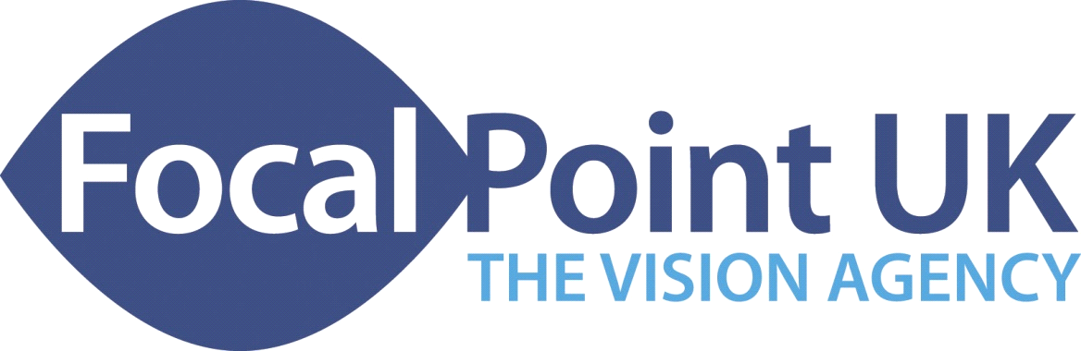
Visual Impairment/Low Vision
Training, Consultancy and Support Services
Web: www.focalpointuk.co.uk

Moving On – Advanced O + M Training

‘easy2see’ Vision Training Series
Andy Fisher – Senior VI Consultant (Vision Rehab + Low Vision)

This one-day advanced Orientation and Mobility Course is for qualified Vision Rehabilitation Workers.

The Course Aim:
To provide O + M training that updates professional practice by reviewing theory and evidence, equipping participants with strategies and options for dealing with more complex O + M situations and identifying possible solutions when working with additional factors and mobility aids

Learning Outcomes - At the end of the course you will be able to:
- State and describe up-to-date theory and principles of O + M practice
- State and explain specific VI issues related to the use of various mobility aids
- Identify the needs of people with VI using mobility aids and ‘associated equipment’
- Identify and compare strategies to integrate VI needs with the use of mobility aids
- Demonstrate mobilisation options and solutions with a range of mobility aids

Programme

Session One
- Welcome and introductions
- Aims, learning outcomes and setting the scene
- Update on O + M Theory and Research
- Manual Handling versus Sighted Guide - making the right 'call'

Session Two
- Getting the right support - working with walking sticks
- Frames in O + M - using walking frames and Rollators

Session Three
- Being mobilised - mobility scooters in O + M
- Wheelchairs - powered and self-propelled

Session Four
- Taking baby for a walk - buggies and prams for O + M
- Evaluation and close

