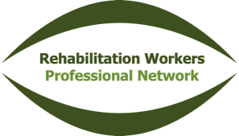
Peer Review
Reflective Learning Statement
Date:

Name of Facilitator:

Summarise the issue or subject(s) that was/were discussed during this session:

List the main things your learned from this session:

Describe how you will apply this learning in your practice:

Has this session identified any areas where further personal learning is needed? If so, briefly describe these below:

